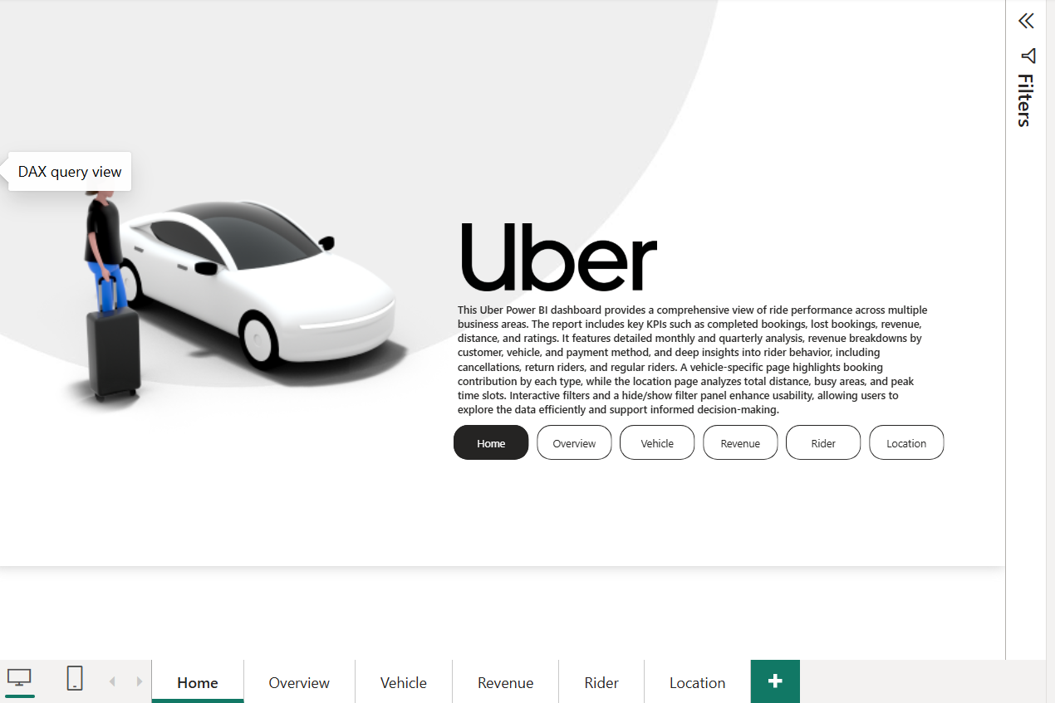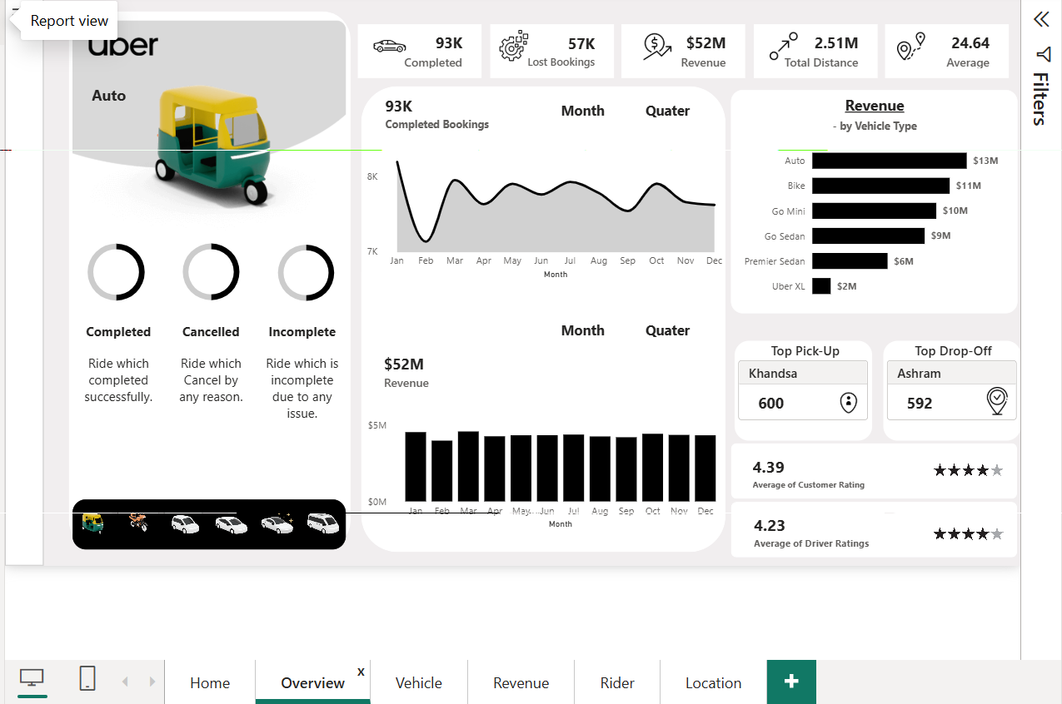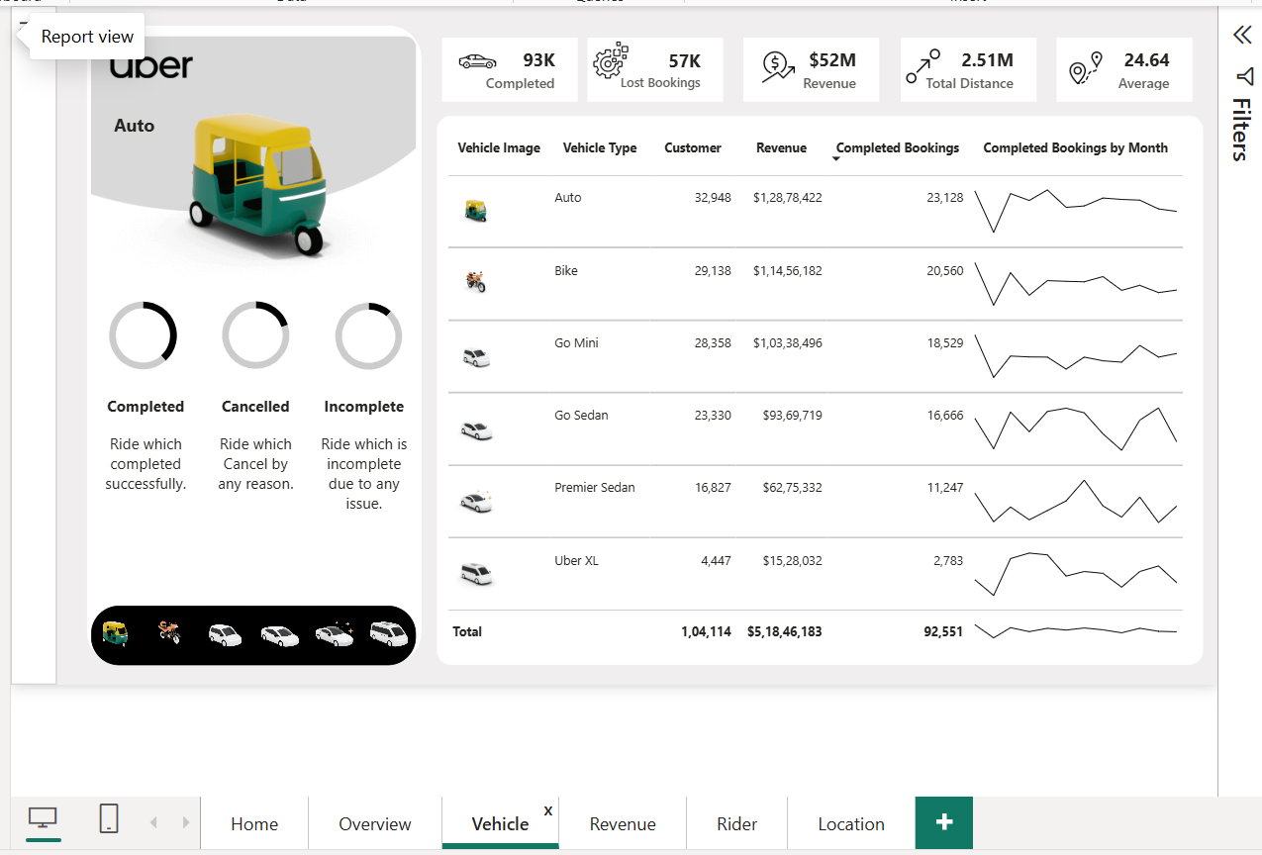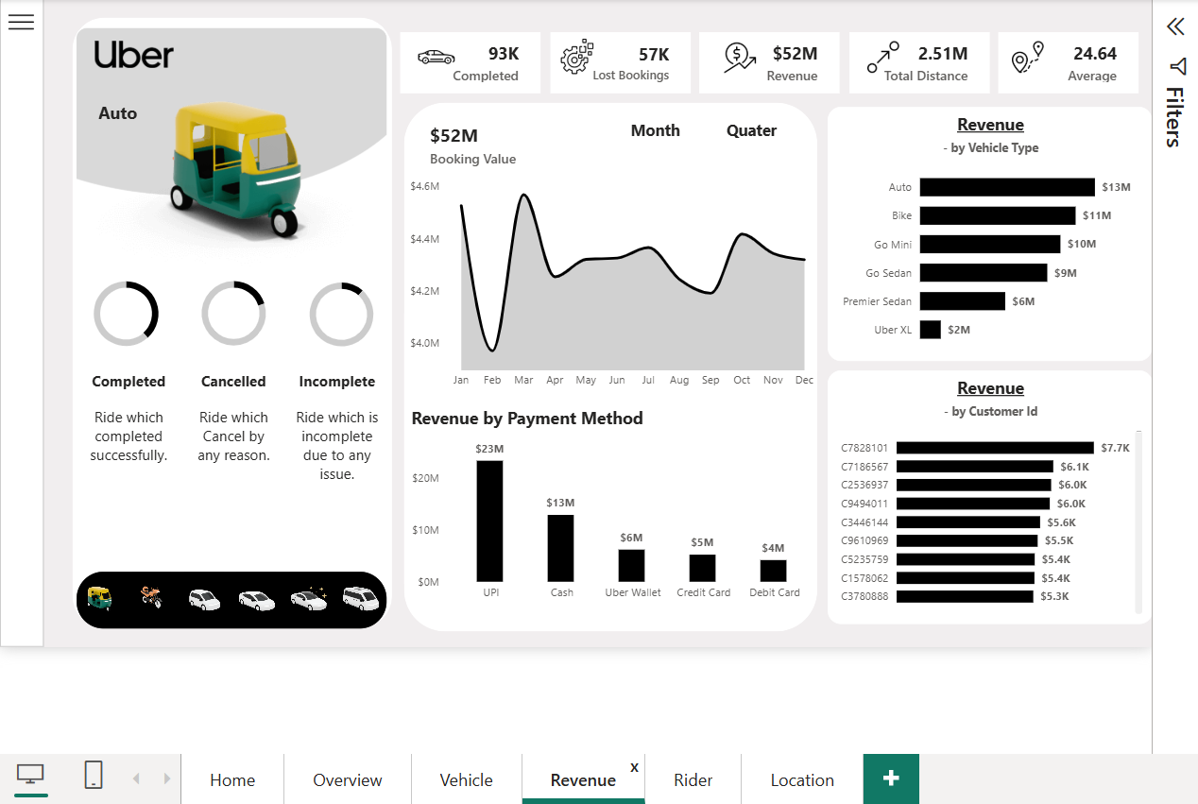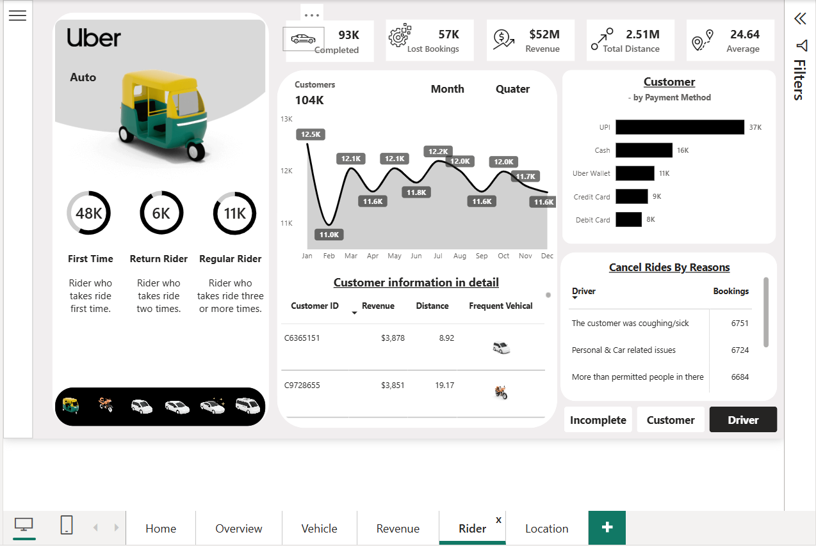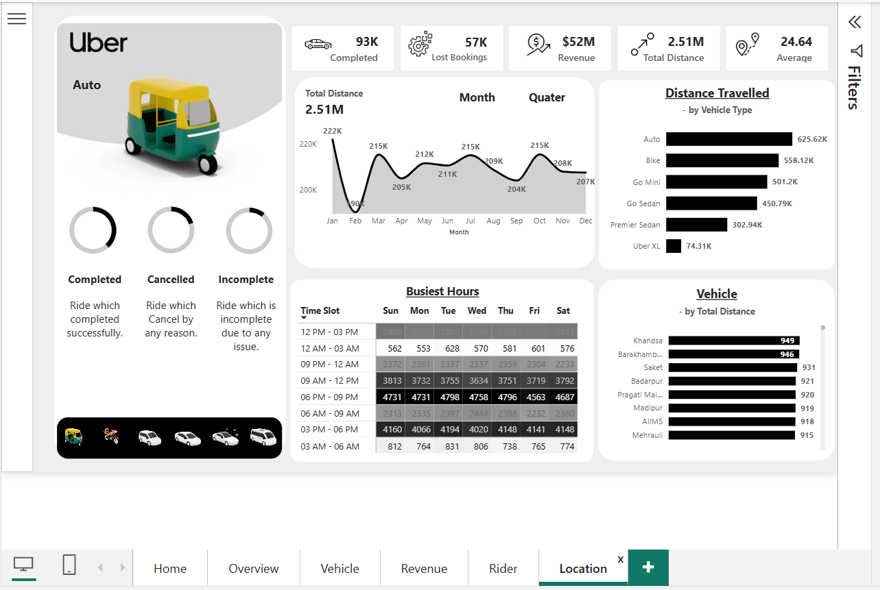

🏆 FINAL OUTPUT FOR YOUR INTERVIEW

Below are the 6 sections you can use in any interview:
1️⃣ 2-Minute Project Storytelling (Short Version)
2️⃣ 5-Minute Project Storytelling (Full Version)
3️⃣ 30+ Interview Questions & Answers (Tailored to Your Dashboard)
4️⃣ Technical Breakdown (DAX, modelling, challenges)
5️⃣ Business Insights Summary
6️⃣ Strengths to Tell Interviewers

⭐ 1. TWO-MINUTE STORYTELLING (Short Version for Interviews)
“My project is an end-to-end Uber analytics dashboard built in Power BI.
The goal was to understand revenue trends, booking behavior, cancellation reasons, and vehicle performance across multiple business areas, even though I did not receive formal requirements — I defined the full scope myself.
I created a clean data model with a Calendar table, time-slots, vehicle type normalization, and several KPI measures.
The Overview page highlights completed bookings, lost bookings, revenue, total distance, and average ride distance along with top pickup/drop locations and ratings.
I then built dedicated pages for Vehicles, Revenue, Riders, and Locations.
These pages provide deeper insights like revenue by vehicle type, revenue by customer and payment method, rider segmentation (first-time, return, regular), cancellation reasons, busy time slots, and distance analysis.
I also added a dynamic Month/Quarter slicer, a dynamic cancellation-reason parameter, and a hide/show filter panel.
By analyzing the data, I found that March had the highest bookings and revenue (~4.56M), UPI was the most used payment method (~23M), Auto generated the highest revenue (13M), and major cancellations were rider-driven.
This dashboard gives a complete view of operational, financial, and customer performance.”

⭐ 2. FIVE-MINUTE STORYTELLING (Full Version for Interviews)
“My project is a portfolio-based Uber analytics solution developed using Power BI.
Since I did not receive fixed requirements, I defined the entire framework myself, identifying real-world business questions Uber would want to solve.
Goal & Problem Statement
The main objectives were:
- Understanding monthly and quarterly revenue trends
- Identifying why bookings are lost (customer cancellation, driver cancellation, incomplete rides)
- Optimizing vehicle performance and contribution
- Analyzing rider behavior (first-time, return, regular riders)
- Understanding busy locations and peak time slots
Data Preparation & Modelling
The dataset contained ~150,000 rows.
I validated data quality in Power Query, defined proper data types, and created:
- A full Calendar dimension
- Month, Quarter, Weekday columns
- Time Slot & Time Slot Sort
- Vehicle Type normalization (VE Type column)
- A dynamic Cancel Ride parameter
- A dynamic Date Axis parameter
- A separate VehicleImages table with images
- Relationships to support slicers & visuals
DAX Measures
I created all core metrics using DAX:
- Completed Bookings
- Lost Bookings
- Revenue
- Total Distance
- Avg Distance
- First-Time, Return, and Regular Rider measures
- Booking Count removing filters
- Contribution % using vehicle normalization
Dashboard Structure
Overview Page: Top KPIs + trend analysis + top pickup/drop + ratings + status doughnut charts.
Vehicle Page: Vehicle-wise revenue, bookings, contribution & completion/cancellation mix.
Revenue Page: Revenue by payment method, customer, and vehicle with monthly & QTR trends.
Rider Page: Rider segmentation, cancellation reasons using dynamic parameter, customer table.
Location Page: Busy time slots (heat map), distance trends, busiest areas.
Key Insights
- Bookings peaked in March and dropped in February.
- Revenue highest in March (~4.56M) and lowest in February (~3.97M).
- Auto generated the highest revenue (13M), followed by Bike (11M) and Go Mini (10M).
- UPI is the most preferred payment mode (~23M).
- Top pickup location: Khandsa (600); top drop location: Ashram (590).
- Average customer rating: 4.39, driver rating: 4.23.
Outcome
The dashboard provides complete operational visibility and enables decisions on:
- Enhancing vehicle supply
- Improving driver and rider experience
- Managing cancellation cases
- Understanding payment preferences
- Increasing revenue forecasting accuracy
This project showed my ability to design dashboards independently, create advanced DAX measures, solve modelling challenges, and provide business value from raw data.”

⭐ 3. TOP 30+ INTERVIEW QUESTIONS & ANSWERS
POWER BI / DAX / MODELLING
Q1. What is the purpose of your Calendar table?
A: To enable correct time intelligence (Month, Quarter, trends) and establish one-to-many relationships with the Uber fact table.
Q2. Why did you create Month Index & Quarter Index?
A: For correct sorting and avoiding alphabetical sorting issues.
Q3. How did you handle Vehicle Type inconsistencies?
A: I created a calculated column VE Type to normalize names (e.g., all bikes categorized as “Bike”).
Q4. Why did the image slicer not work initially?
A: Because images were linked incorrectly. I solved it by creating a new vehicle image DATATABLE and building a proper relationship.
Q5. Difference between Completed Bookings and Lost Bookings measure?
A: Completed filters Booking Status = "Completed".
Lost Bookings uses Booking Status <> "Completed".
Q6. Why did you use ALL() inside CALCULATE?
A: To remove slicer filters for % contribution.
Q7. How did you calculate First-Time, Return, and Regular riders?
A: Using SUMMARIZE grouped by Customer ID and applying row count filters.
Q8. What visualizations did you use for cancellations?
A: A parameter-driven dynamic slicer & matrix to show cancellation by customer, driver, incomplete.
Q9. Why create Time Slot Sort column?
A: To ensure time slots appear in correct chronological order, not alphabetically.
Q10. Describe your data model.
A: Star schema with Uber fact table, Calendar table, Vehicle Images dimension, and parameters.

BUSINESS & ANALYTICAL
Q11. What was the biggest business insight?
A: Bookings & revenue peak in March; Auto & Bike are highest revenue contributors.
Q12. What do cancellation insights tell the business?
A: Focus needed on driver and customer communication, and incomplete rides suggest operational gaps.
Q13. What does payment method insight tell you?
A: Digital payments (UPI) dominate, so Uber should enhance UPI rewards/discounts.
Q14. Why are weekday/time slot insights important?
A: Helps optimize driver allocation and reduce waiting time.
Q15. What should Uber do with top pickup/drop areas?
A: Increase vehicle supply in Khandsa and improve service experience around Ashram.

TOOLS / IMPLEMENTATION
Q16. Why did you add a hide/show filter panel?
A: To save page space and keep the UI clean.
Q17. Any challenges with modelling?
A: Yes — vehicle image slicer issues and creating a correct dimension table.
Q18. What KPIs did you present and why?
A: Completed Bookings, Lost Bookings, Revenue, Distance → they show business health.
Q19. How did you ensure dashboard performance?
A: Used measures instead of calculated columns, minimized visuals per page, created dimension tables.
Q20. Why create a separate Vehicle Page?
A: Stakeholders like fleet managers need vehicle-level insights for optimization.

SCENARIO QUESTIONS
Q21. If cancellation rate increases next month, how would you detect the cause?
A: Compare Reason for cancellation across customer vs driver vs incomplete using the parameter.
Q22. If revenue dips, what would you analyze first?
A: Vehicle performance → payment method mix → cancellation trends → time slot patterns.
Q23. How would you improve this dashboard further?
A: Add forecasting, drillthrough pages, clustering for customer segmentation.

⭐ 4. TECHNICAL BREAKDOWN (What You Say in Interview)
Data Modelling
- Star schema: Uber Fact + Calendar Dimension + VehicleImages Dimension.
- Relationships: Date (Calendar → Uber), Vehicle Type (Images → Uber).
DAX Measures
You used:
- CALCULATE with filters
- ALL() to remove filters
- DISTINCTCOUNT for customers and booking counts
- SUMMARIZE for segmentation
- Custom ranking columns
- Parameters using DAX ordered tables
Transformations
- Normalized Vehicle Type
- Time Slot classification
- Time Slot Sort
- Calendar table construction
- No data cleaning needed, only data typing
Advanced Features
- Dynamic axis parameter (Month/QTR)
- Dynamic cancellation type parameter
- Vehicle image slicer
- Hide/show filter panel

⭐ 5. KEY BUSINESS INSIGHTS SUMMARY (Use These in Interviews)
- March is the peak month for both bookings and revenue.
- Auto generated the highest revenue (13M).
- UPI is the most preferred payment method (~23M).
- Khandsa is the busiest pickup location; Ashram top drop.
- Customer rating (4.39) > Driver rating (4.23).
- Booking dropped sharply in February and recovered later.
- Rider segmentation shows a healthy mix of first-time, return, and regular riders.

⭐ 6. UNIQUE STRENGTHS TO TELL INTERVIEWERS
- You built the entire requirement yourself, displaying initiative.
- You used dynamic parameters to make the dashboard highly interactive.
- The vehicle image slicer and hide/show filter panel reflect good UI/UX design.
- You combined operational, financial, customer, and geographical analysis in one project.
- You demonstrated end-to-end BI skills: modelling, DAX, visualization, storytelling.

⭐ Best Combined Bullet (Use on Resume)
Designed and developed a full end-to-end Uber Analytics Dashboard in Power BI (150K+ rows), including star-schema modelling, custom DAX measures, dynamic parameters, vehicle image slicers, and multi-page reports covering KPIs, revenue trends, cancellation reasons, rider segmentation, vehicle performance, and location/time-slot analysis to support actionable operational insights.

